1. Assignment on N-map, and
2. Packet Snipping using Wireshark.

## **Submission To:**

## Mr. Mohammad Zainal Abedin

## Assistant Professor

## Department of Computer Science & Engineering

## International Islamic University Chittagong

### **Submitted By:**

### Mahadi Hasan

### ID: MC233107

### MSc in CSE

### Email: [mahadeh575@gmail.com](mailto:mahadeh575@gmail.com)

### Department of Computer Science & Engineering

### International Islamic University Chittagong

**Exercise 1: Nmap Practice**

In the following exercise I have used these commands.

1.Vision Check: Nmap -V -A scanme.nmap.org

2. Scanning Website: Nmap Facebook.com

3. Host Discovery – traceout: sudo nmap-traceout 51.23.48.15

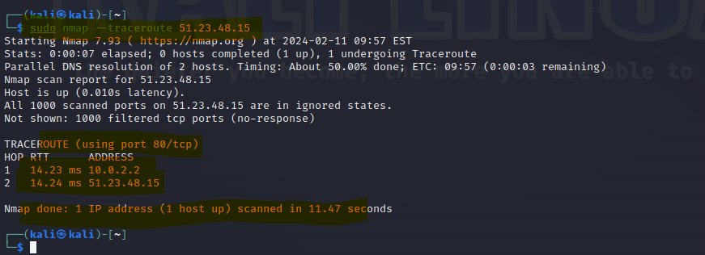

4. Port Specification: **nmap 45.33.32.156-200 -p200**

**Exercise 2: Wireshark Practice**

Wifi Capture:

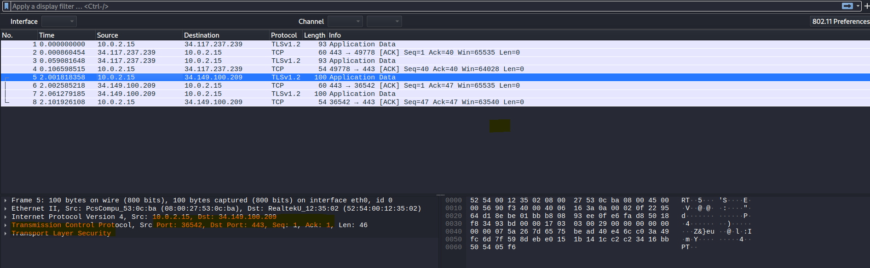

**Thank You.**